**Data Engineering Assignment-4**

**Aggregate Functions in SQL:**

There are different aggregate functions available in SQL. They are:

* **COUNT ():** COUNT function is used to Count the number of rows in a database table. It can work on both numeric and non-numeric data types.

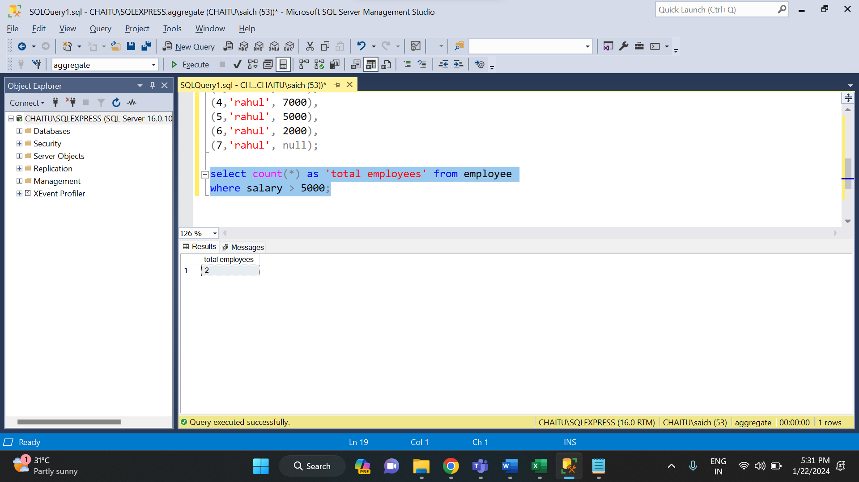

* **SUM ():** Sum function is used to calculate the sum of all selected columns. It works on numeric fields only.
* 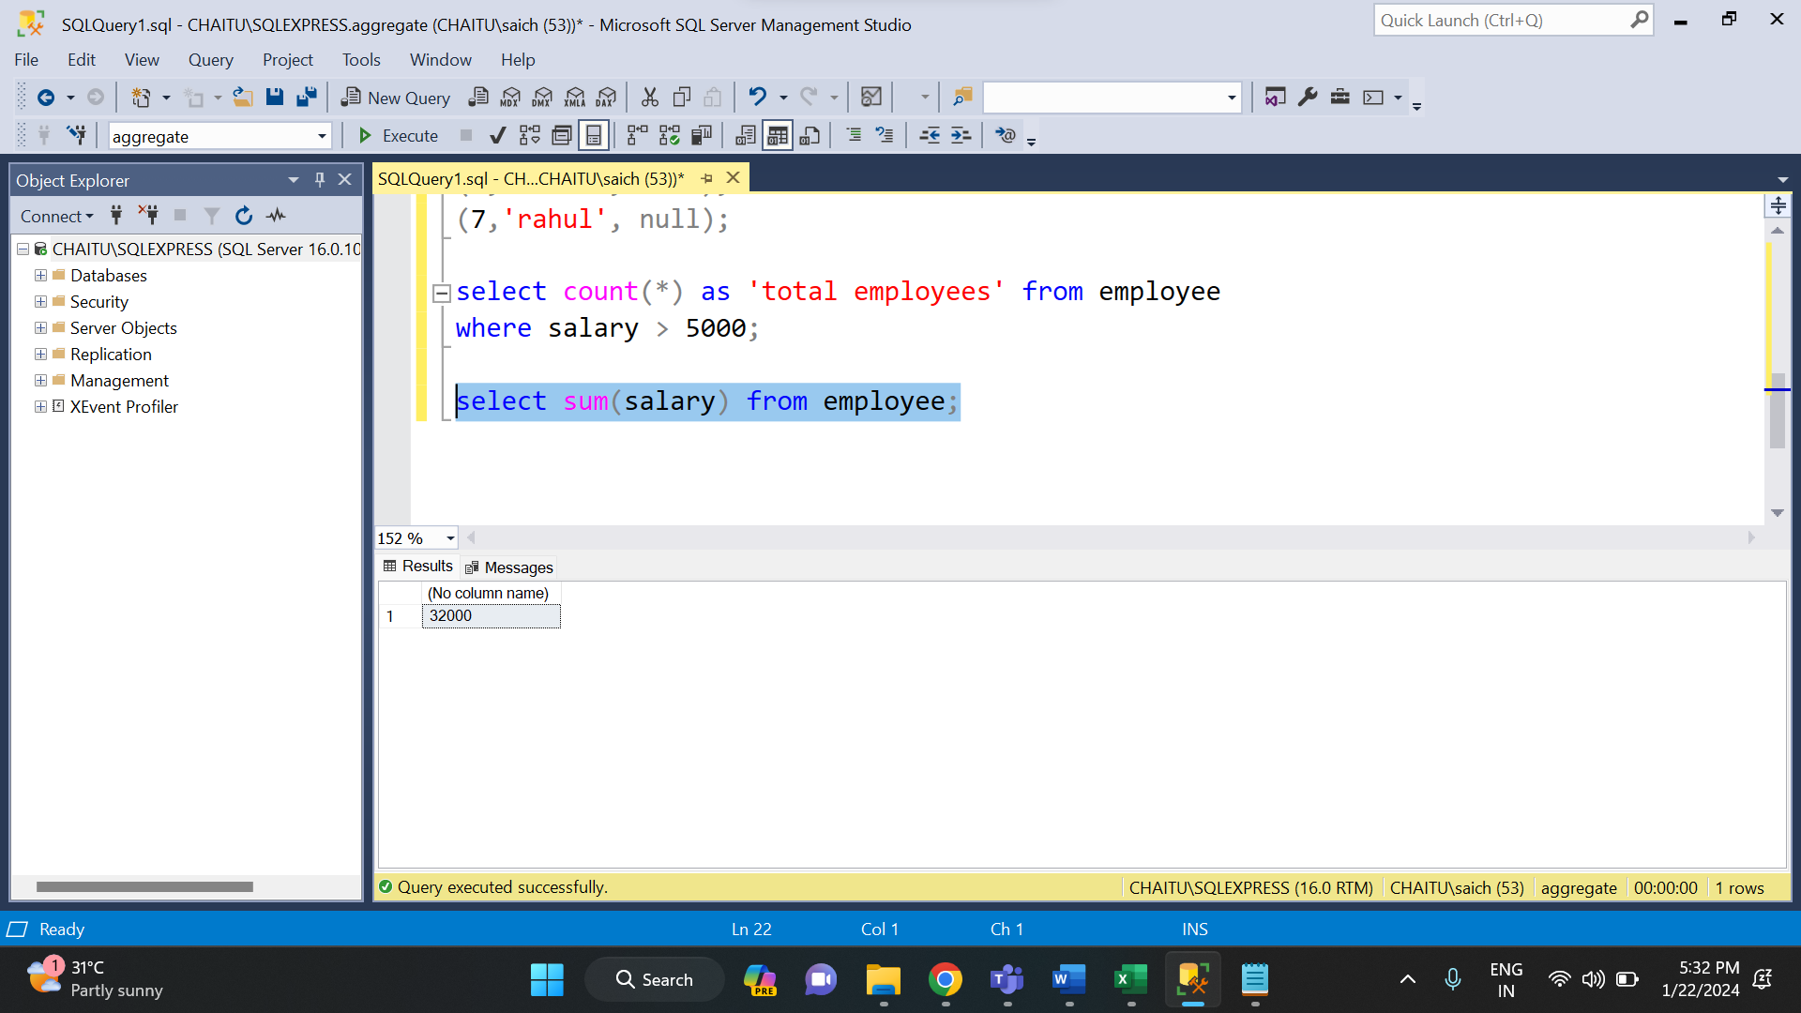
* **AVG ():** The AVG function is used to calculate the average value of the numeric type. AVG function returns the average of all non-Null values.

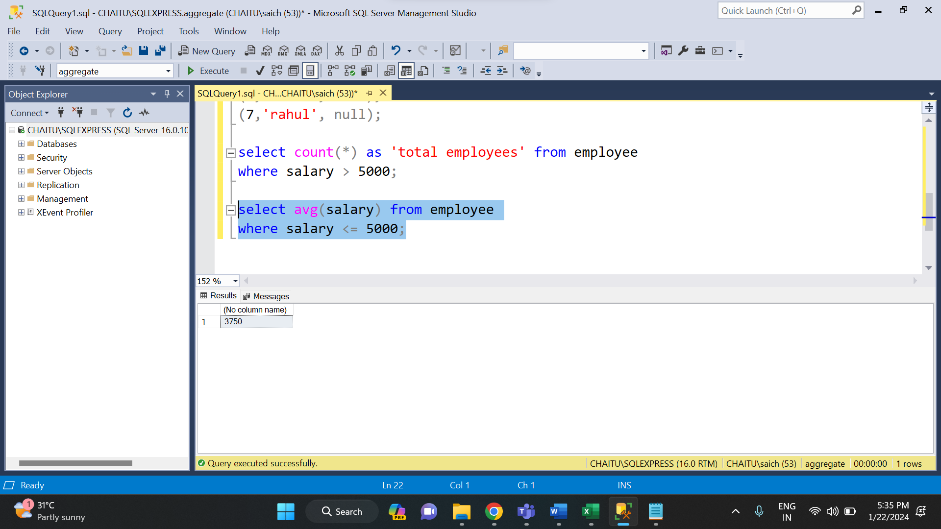

* **MAX ():** MAX function is used to find the maximum value of a certain column. This function determines the largest value of all selected values of a column.

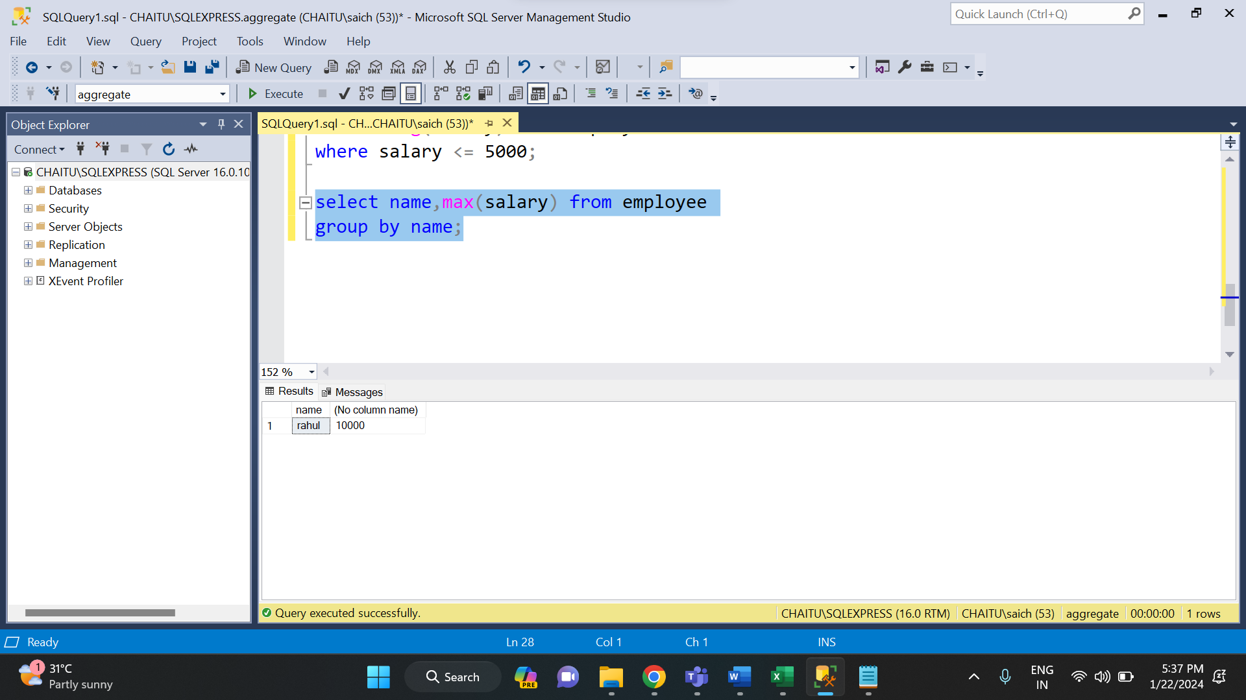

* **MIN ():** MIN function is used to find the minimum value of a certain column. This function determines the smallest value of all selected values of a column.

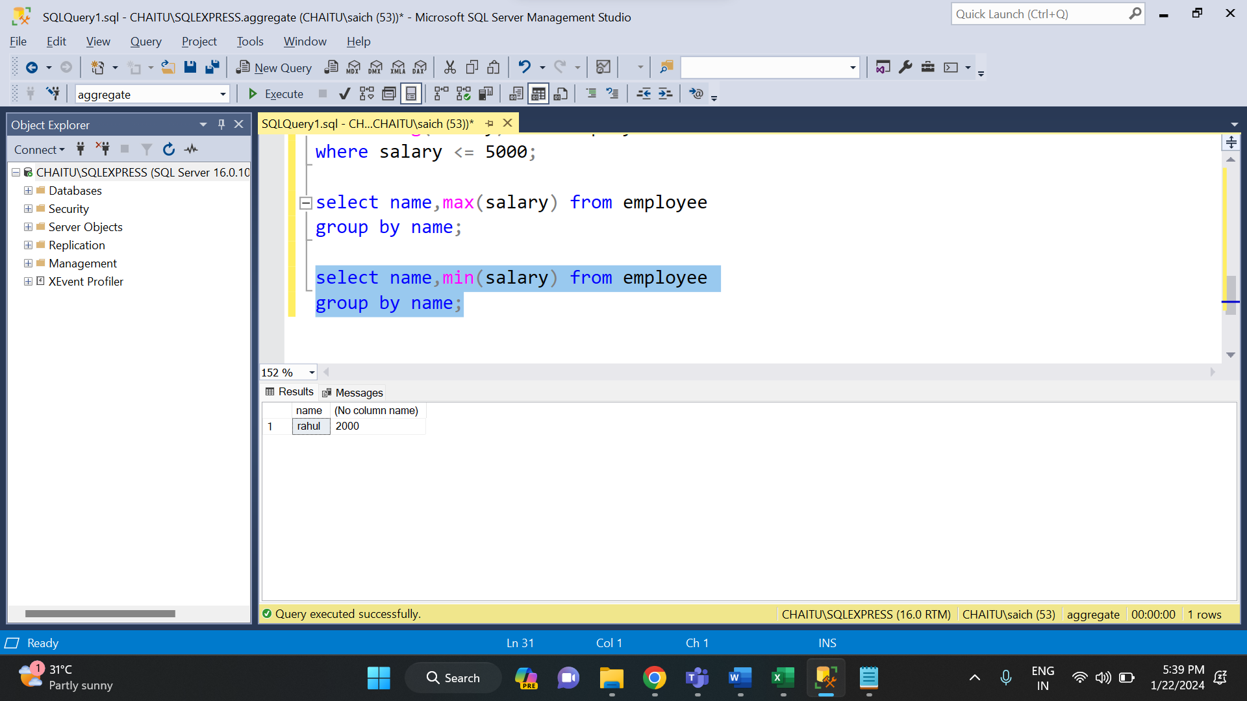

**SUBQUERIES:**

In SQL a Subquery can be simply defined as a query within another query. In other words, we can say that a Subquery is a query that is embedded in WHERE clause of another SQL query. Important rules for Subqueries:

Example: 1

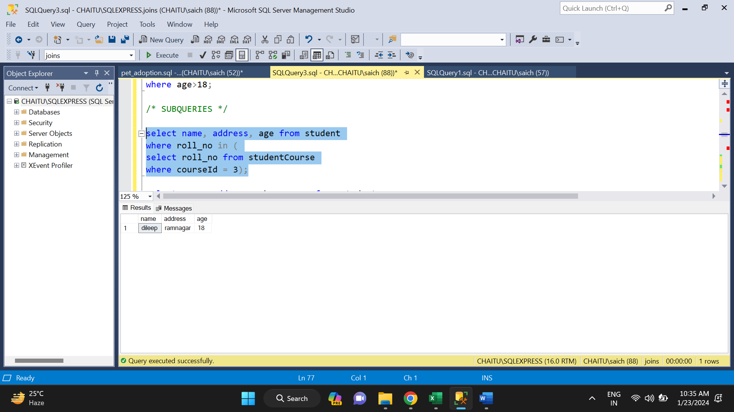

Example: 2

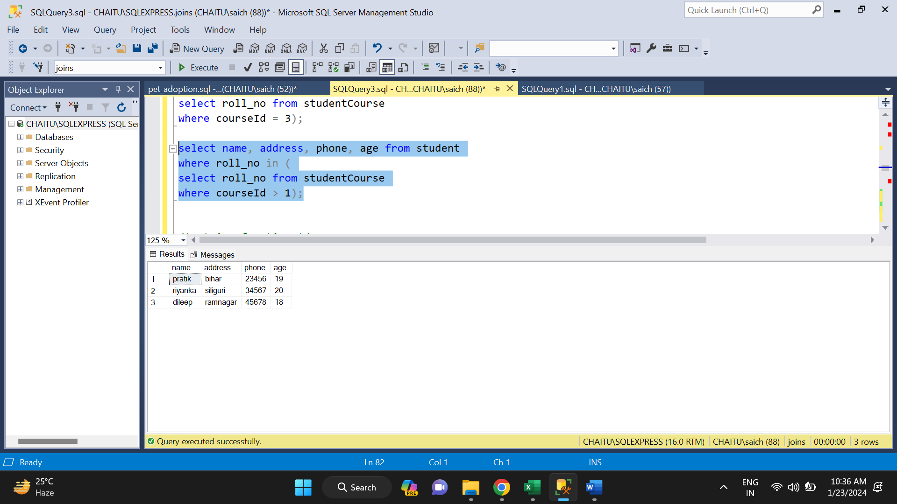

**STRING FUNCTIONS IN SQL:**

There are various string functions in SQL. They are

* **ASCII ():** Returns ascii value of first character

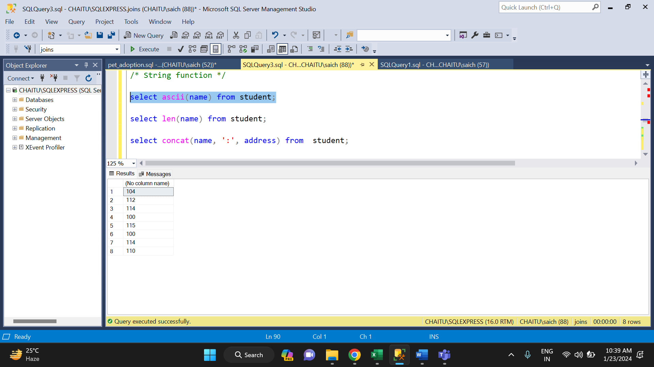

* **LEN ():** Return the length of a string

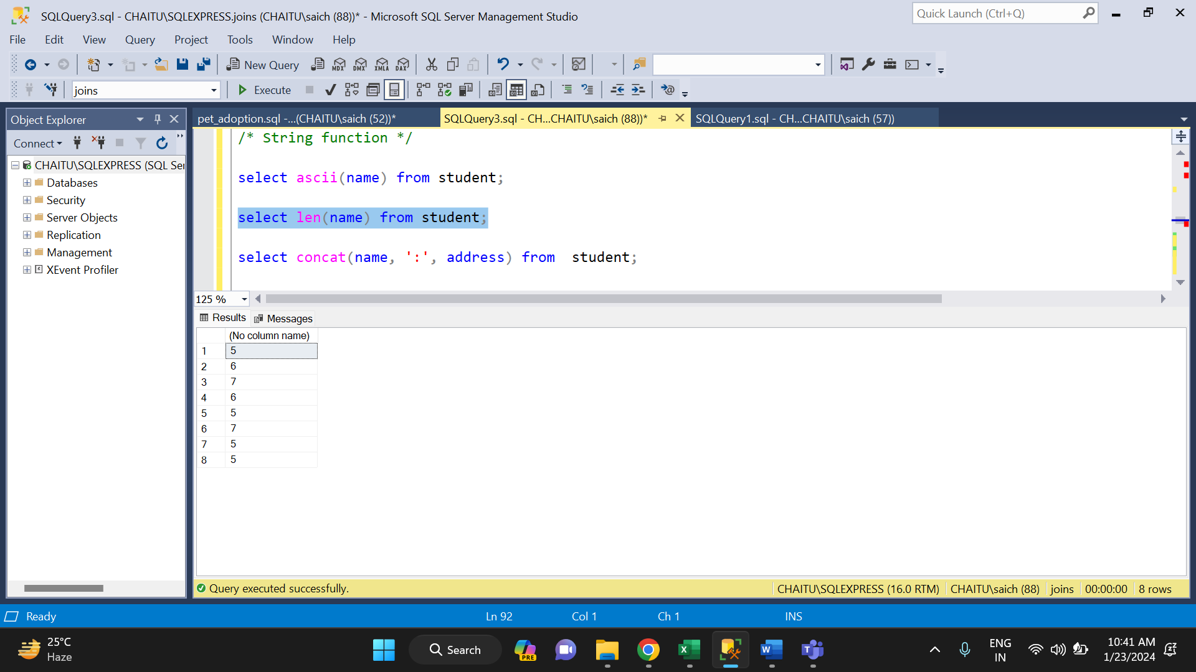

* **CONCAT ():** It is used to add two or more string together

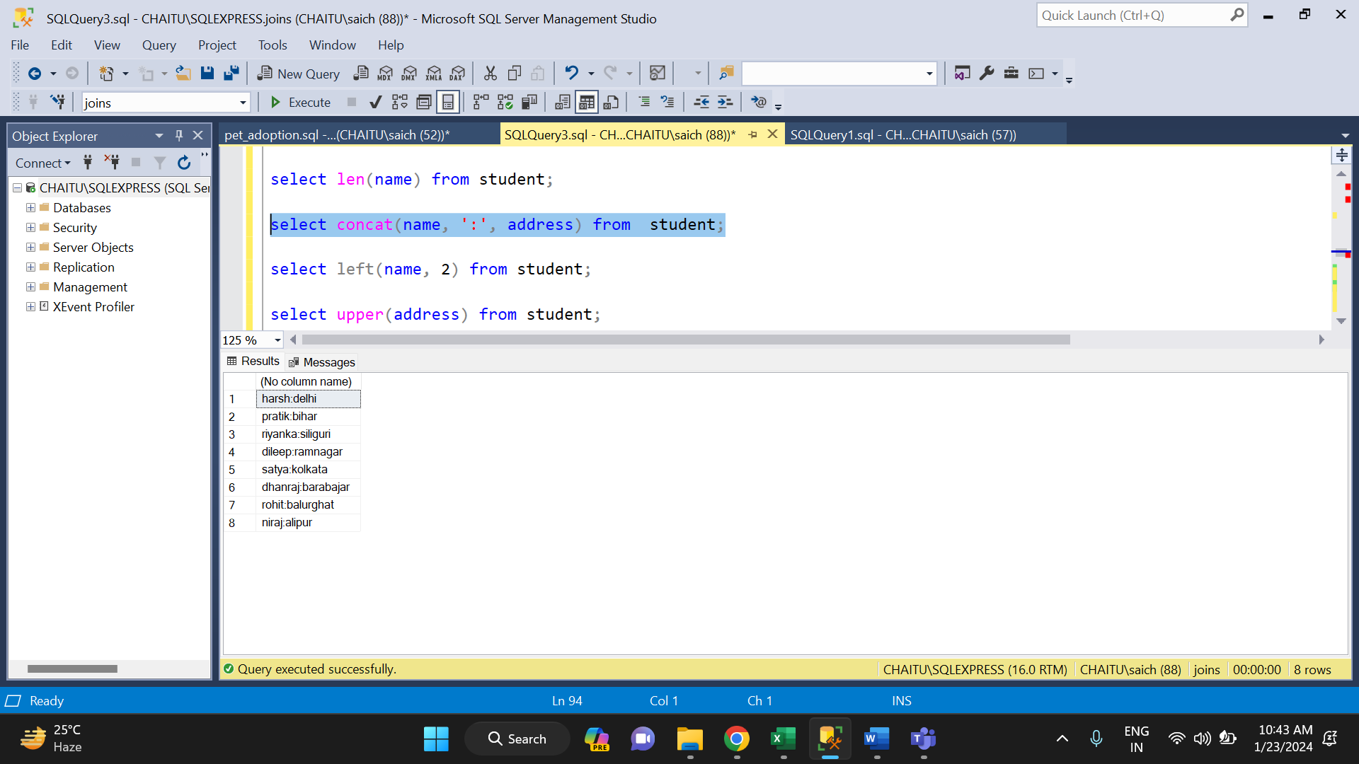

* **LEFT ():** It is used to extract number of characters from a string starting from left.

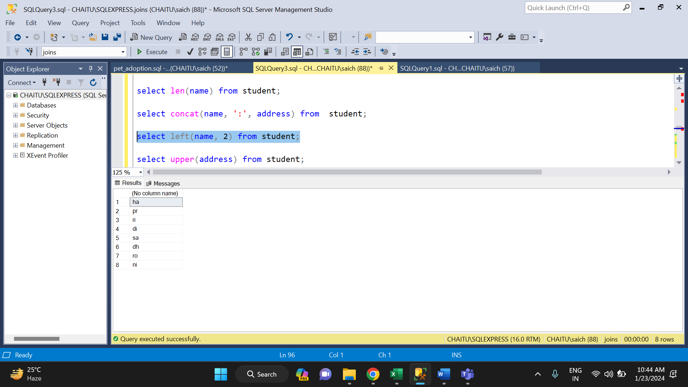

* **UPPER ():** It is used to convert a string into upper case and similarly we have LOWER ().

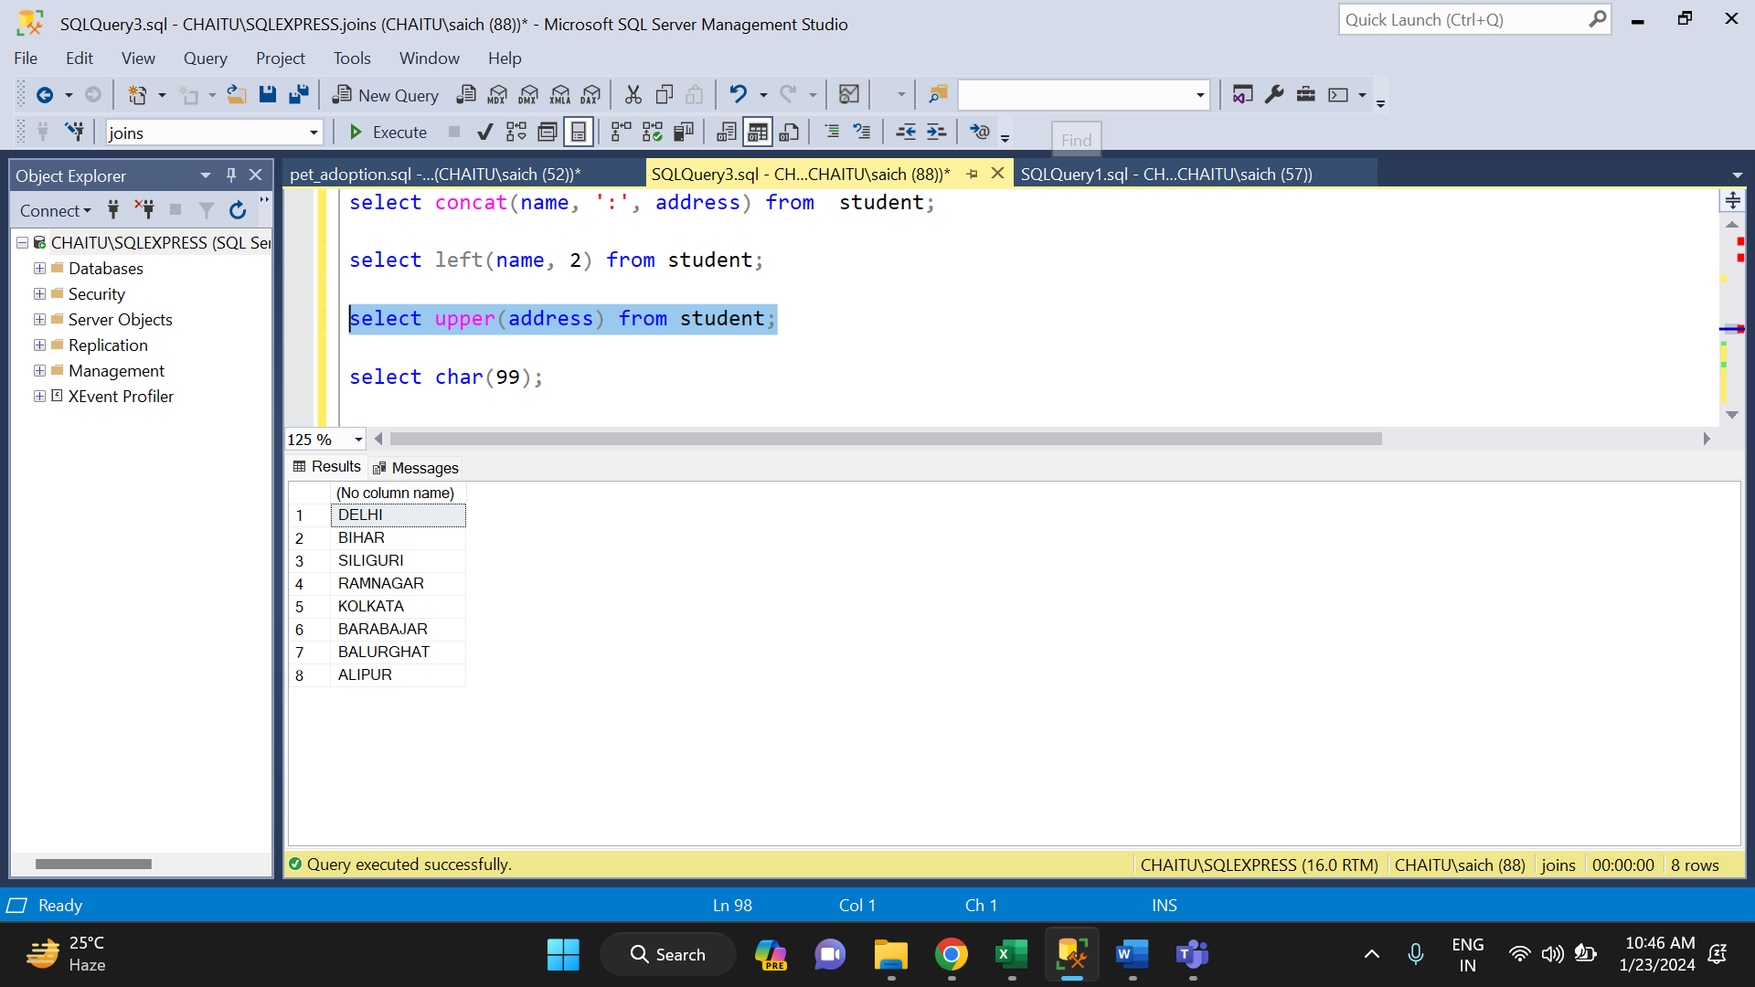

* **CHAR ():** This function returns the character based on character code.

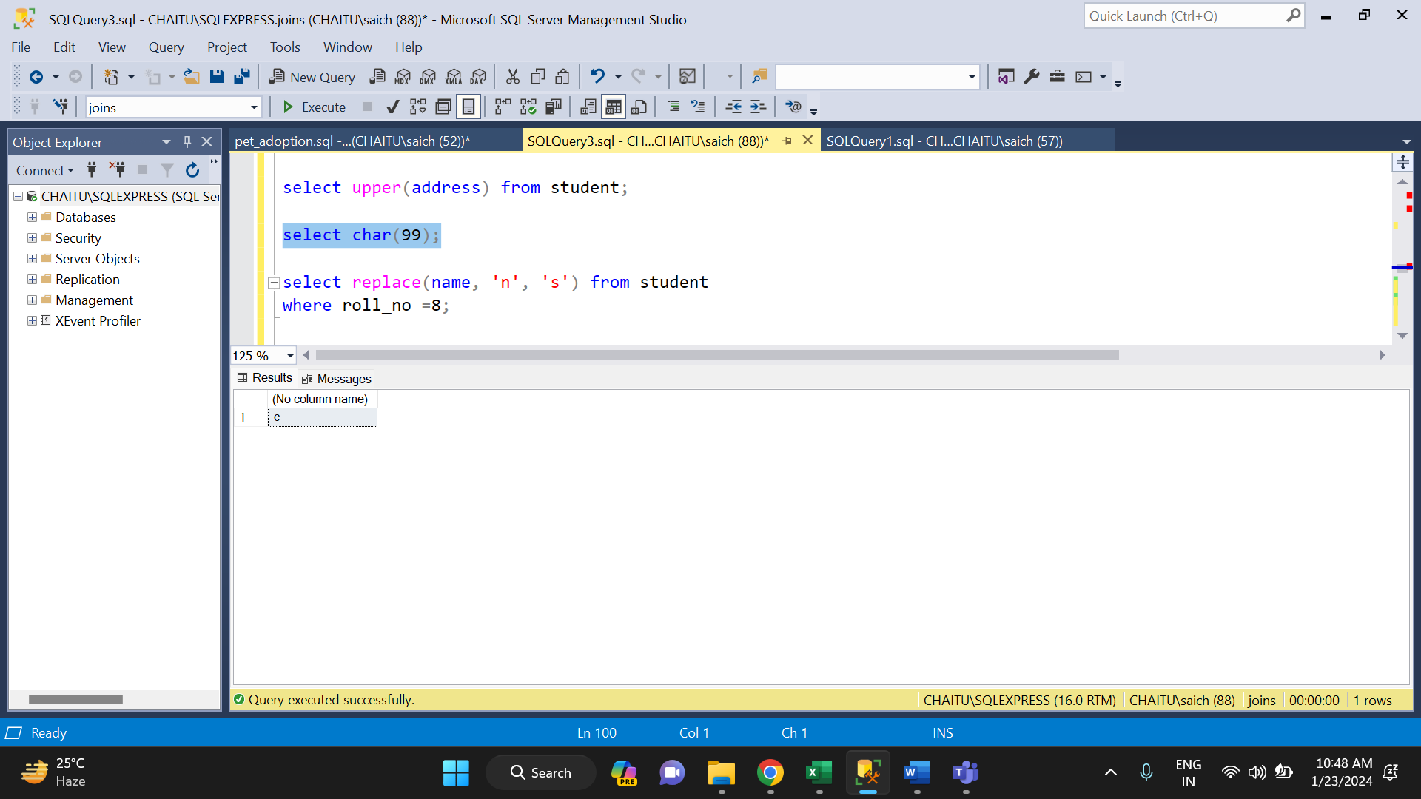

* **REPLACE ():**  It replaces all occurrences of a substring within a string, with a new substring.

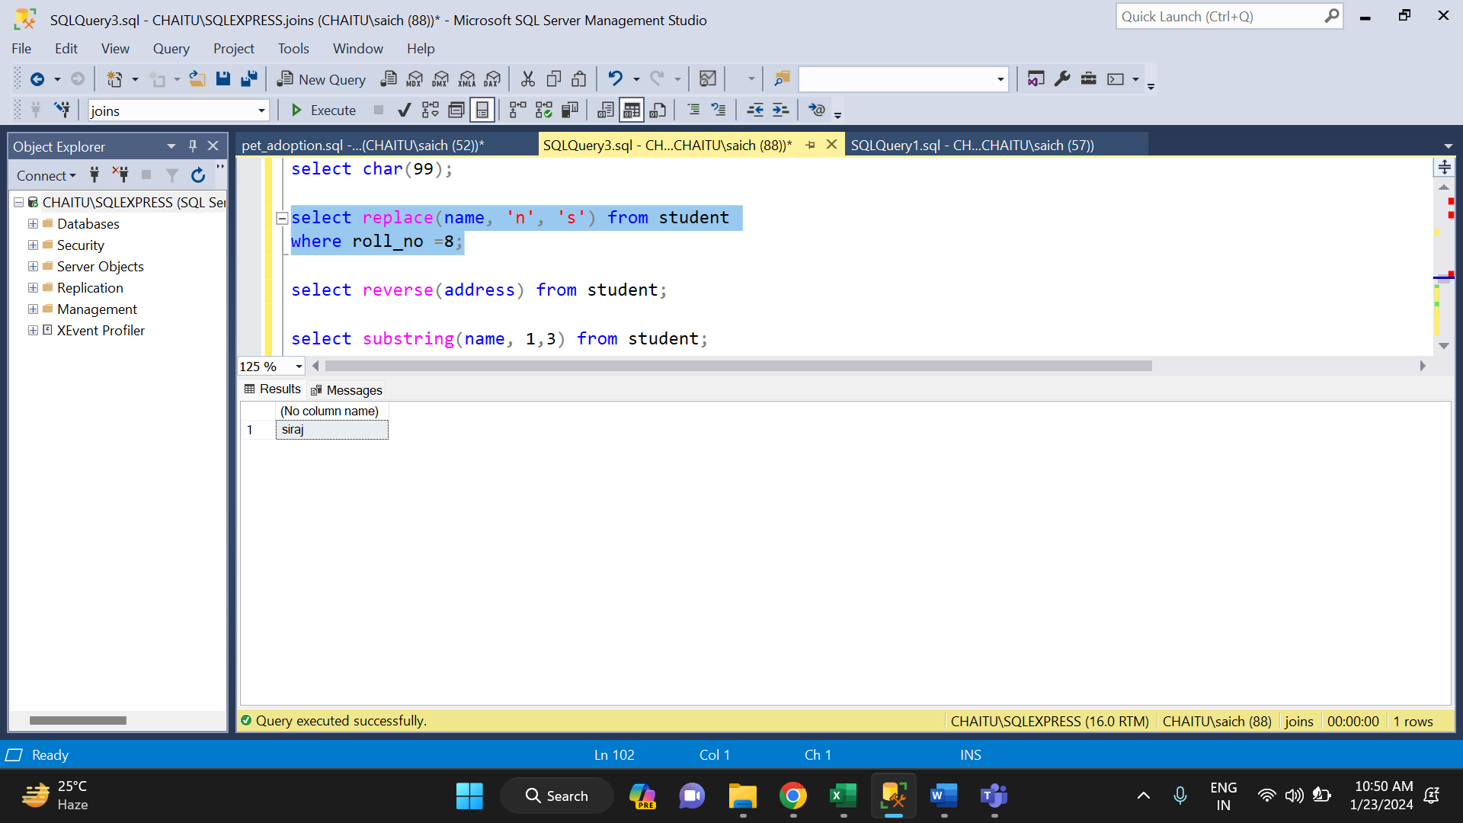

* **REVERSE ():** It is used to reverse a string.

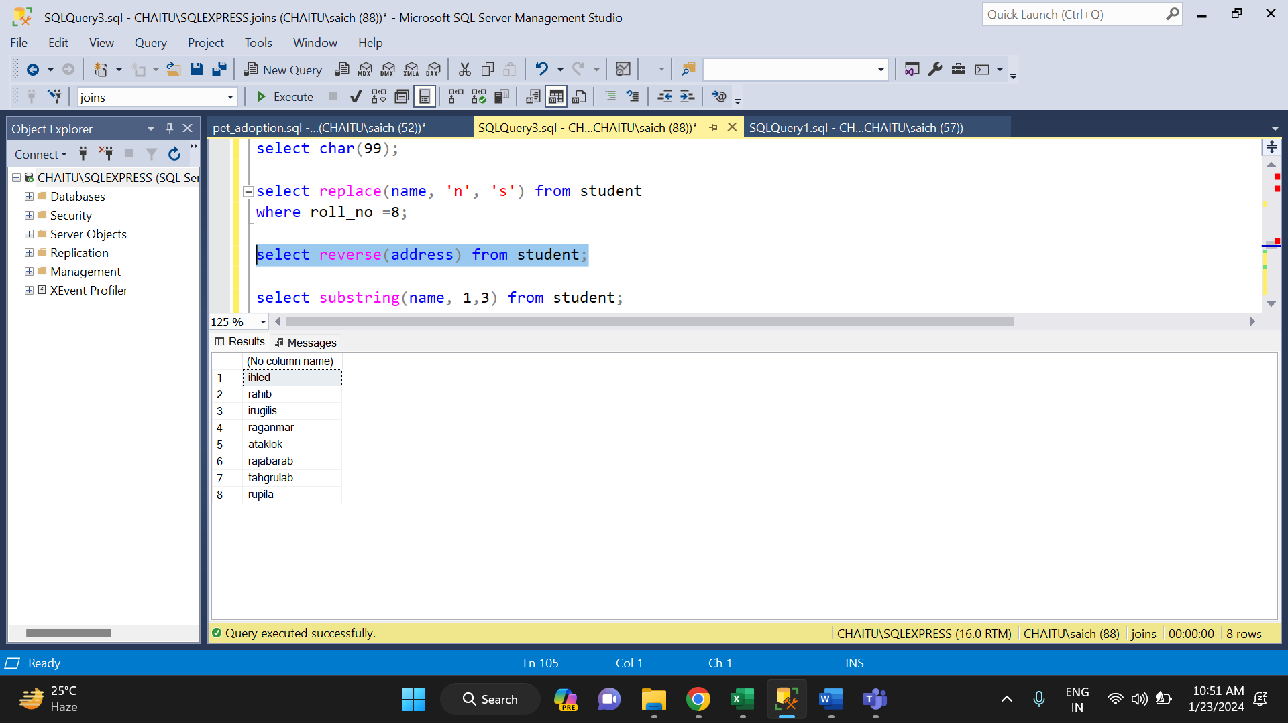

* **SUBSTRING ():** It is used to extract set of character from main string and returns them.

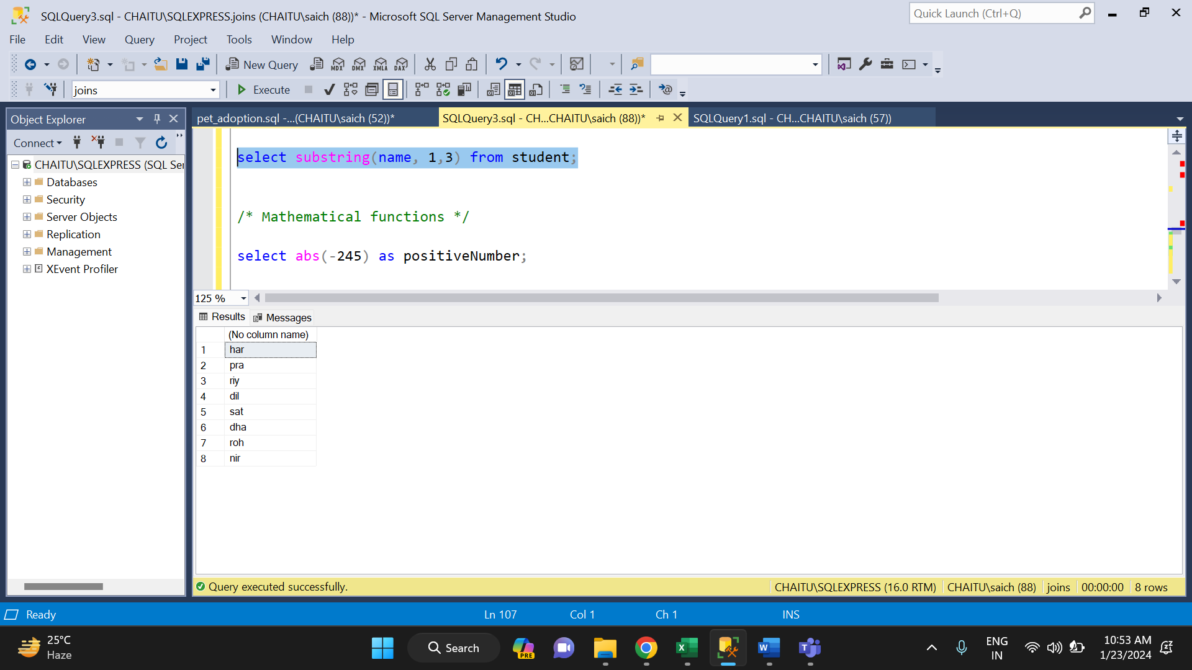

**MATHEMATICAL FUNCTIONS IN SQL:**

There are various mathematical functions in SQL. They are:

* **ABS ():** It return the absolute value.

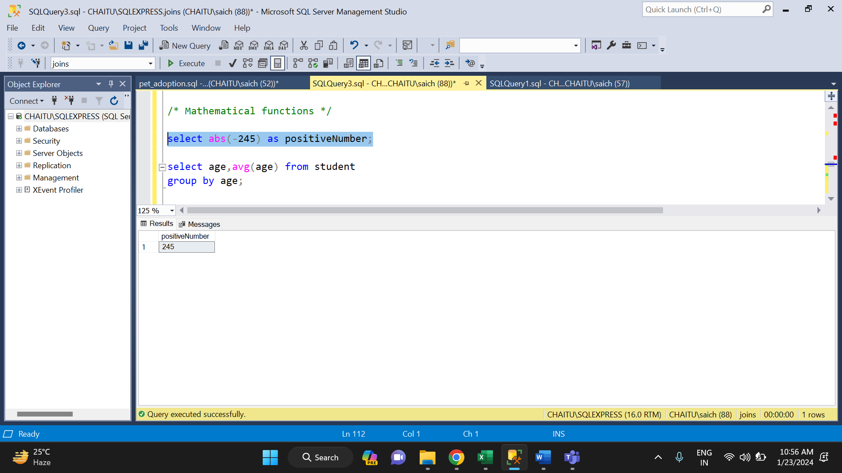

* **AVG ():** It return the average value of an expression.

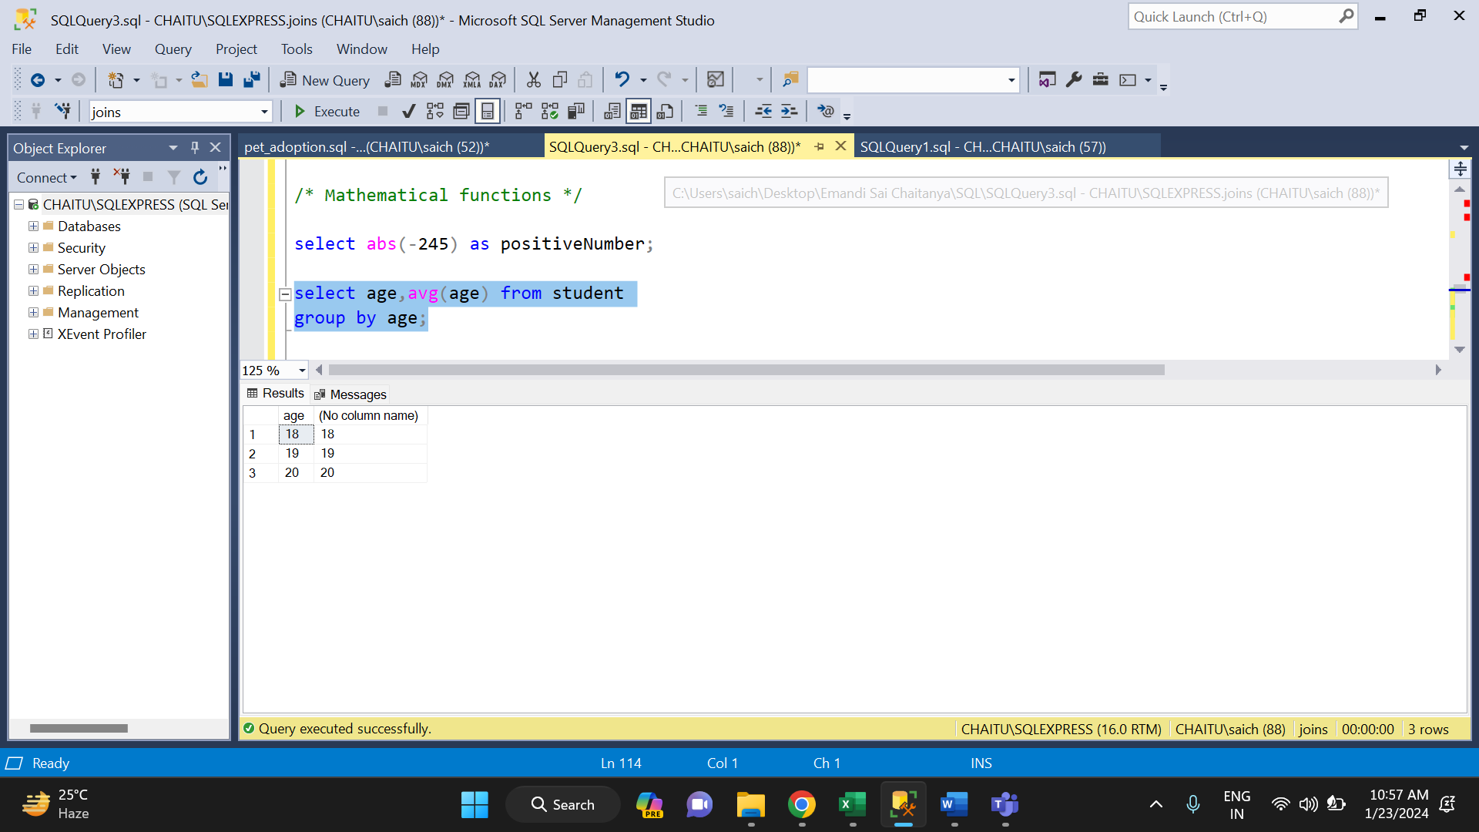

* **CEILING ():** The CEILING () function returns the smallest integer value that is larger than or equal to a number.

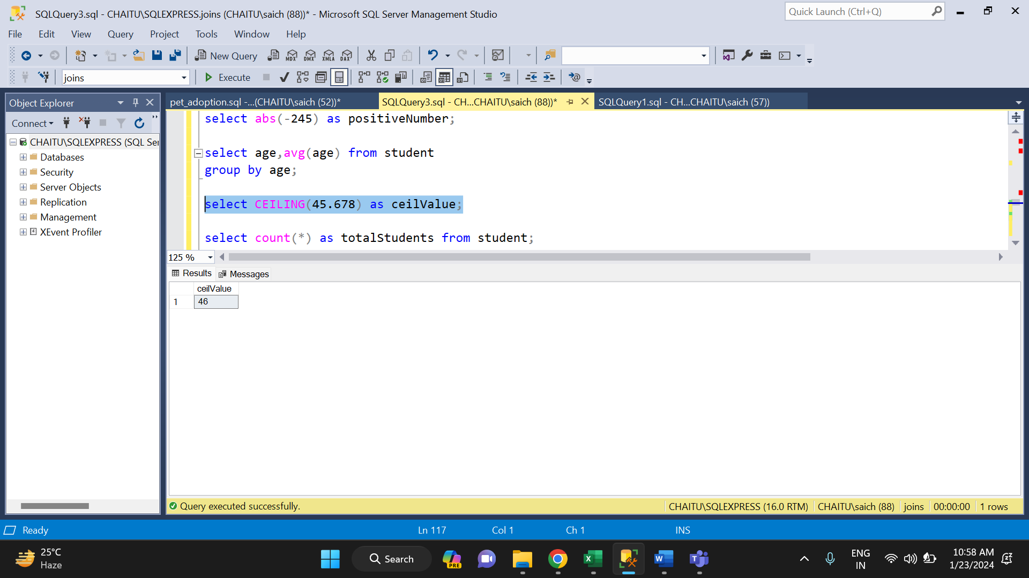

* **COUNT ():** It is used to count the total number of records.

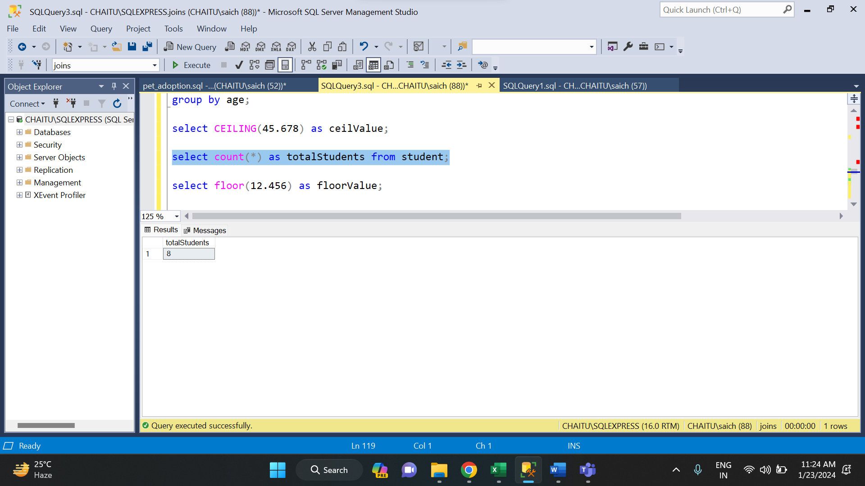

* **FLOOR ():** Return floor value of a number

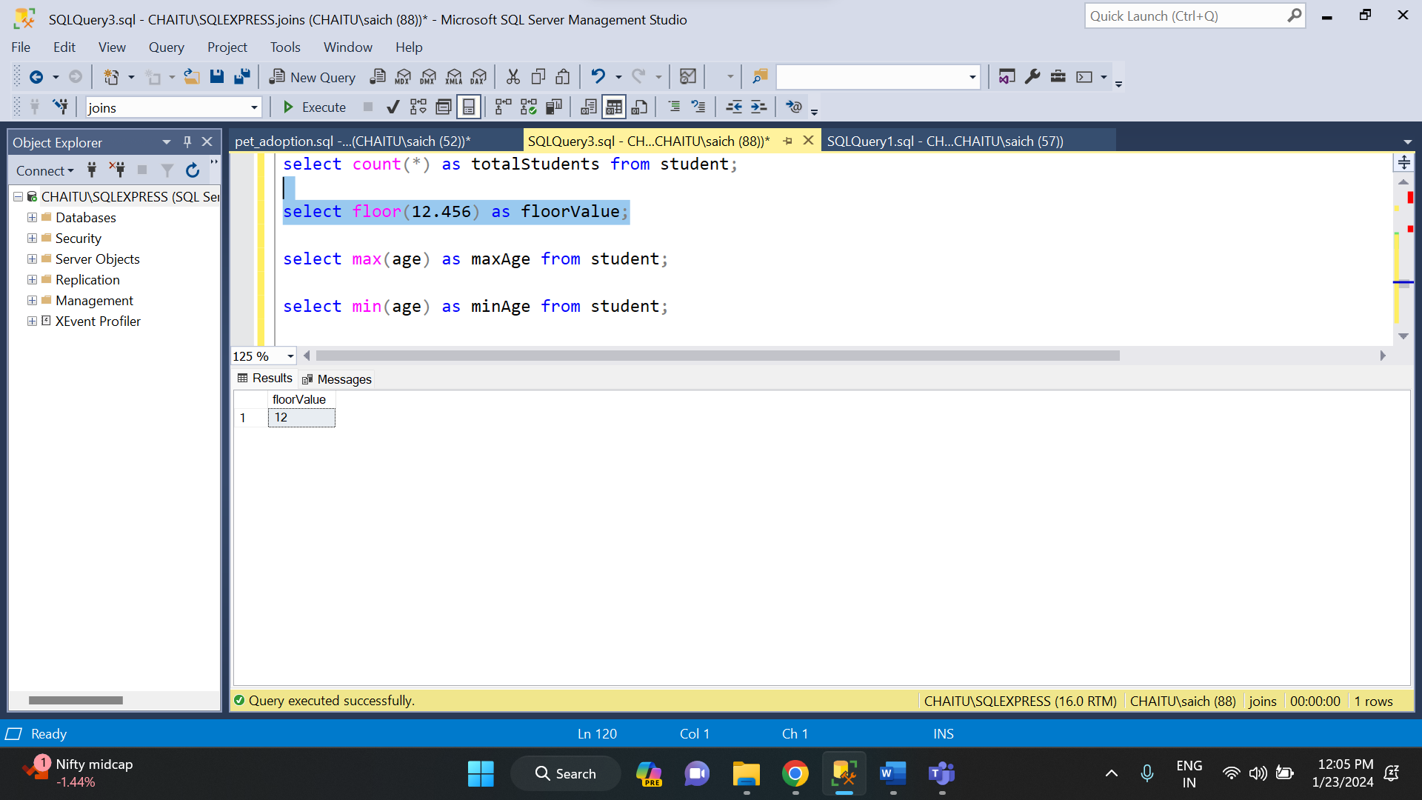

* **POWER ():** Returns the power of a number.

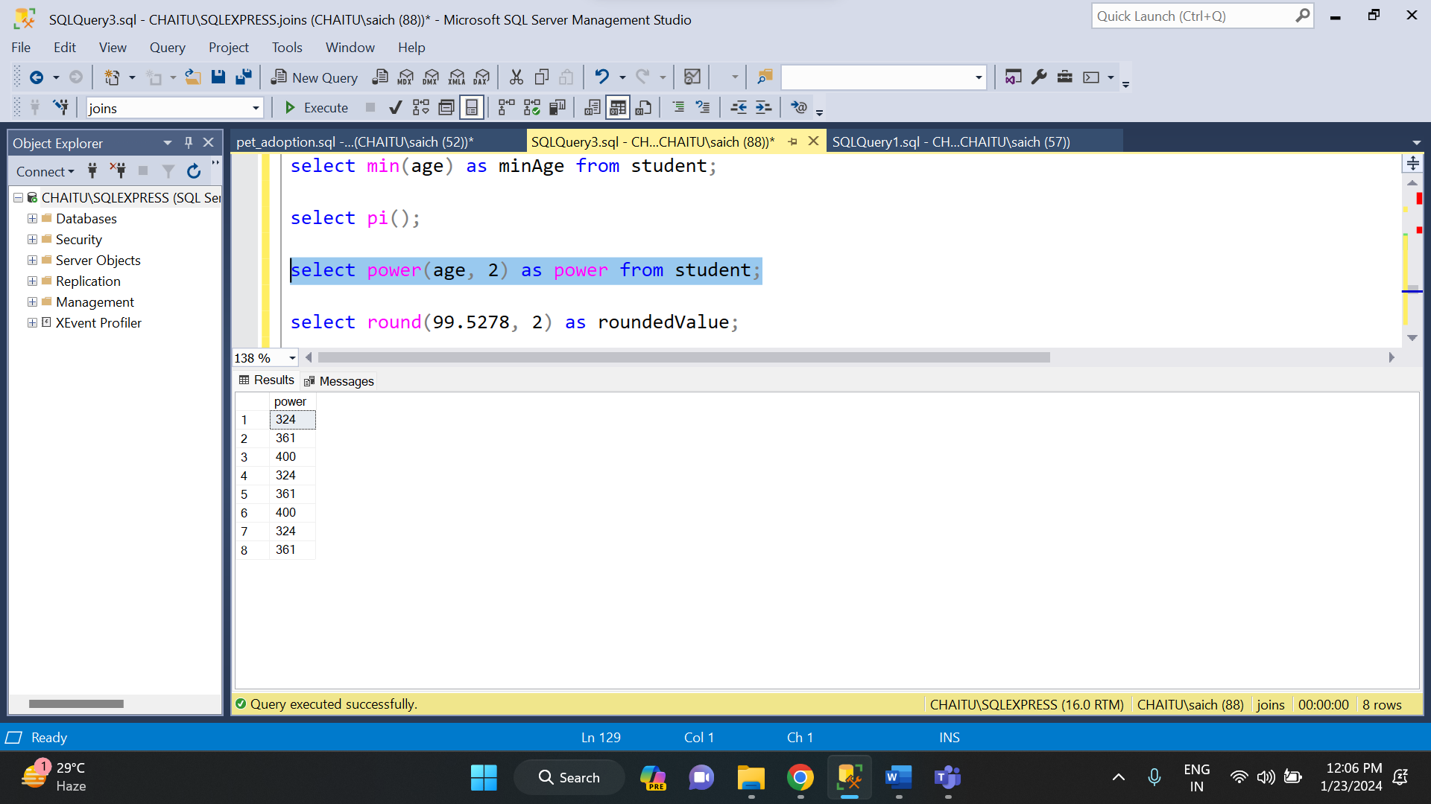

* **ROUND ():** It returns the rounded value of an integer.

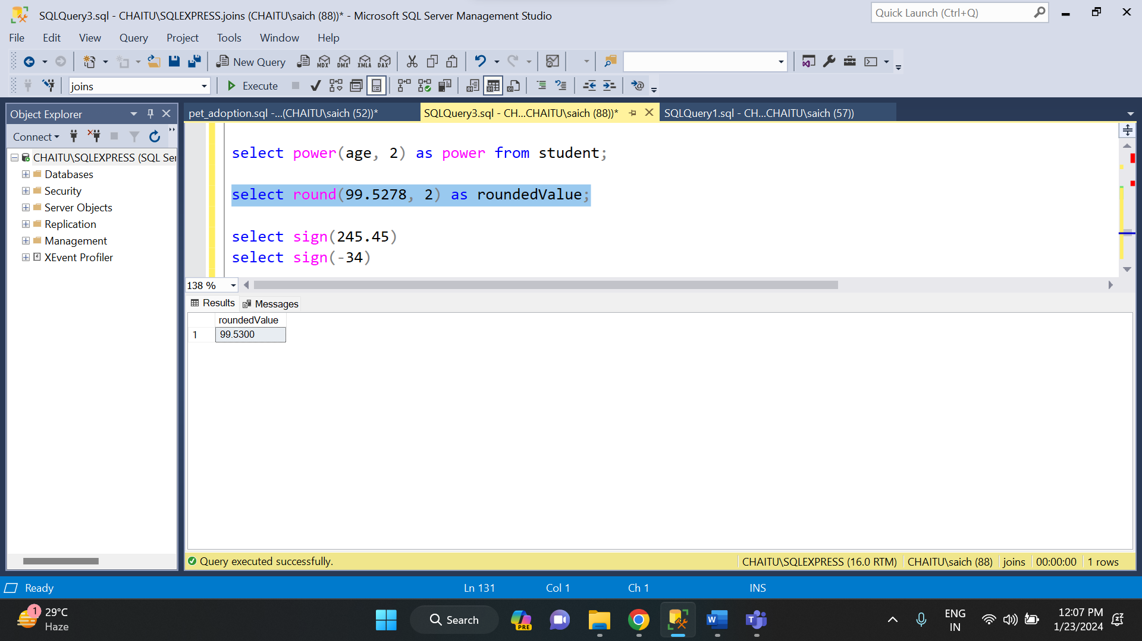

* **SIGN ():** It returns 1 if number is positive, 0 if number is 0 and -1 if the number is negative.

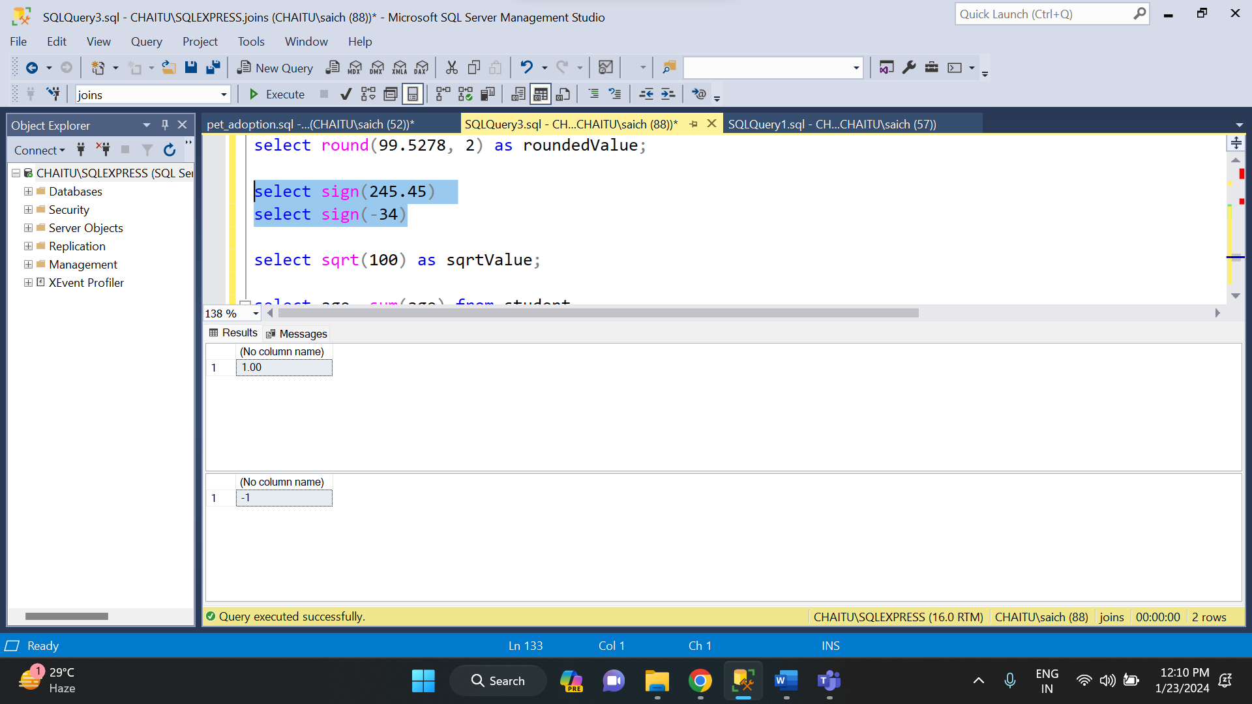

* **SQRT ():** It returns the square root of a number.

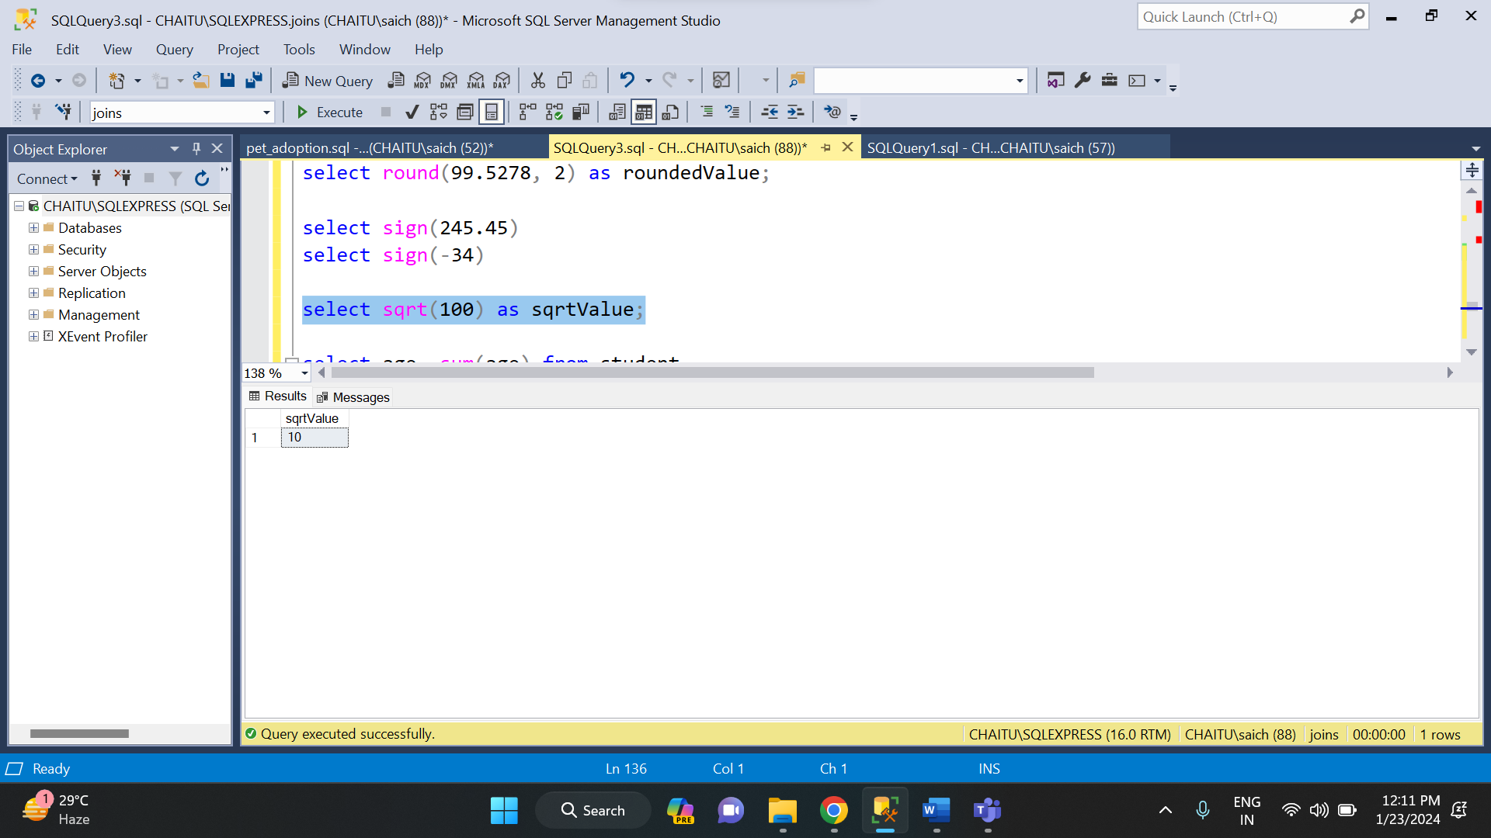

* **RAND ():** The random function is used to return some random value.

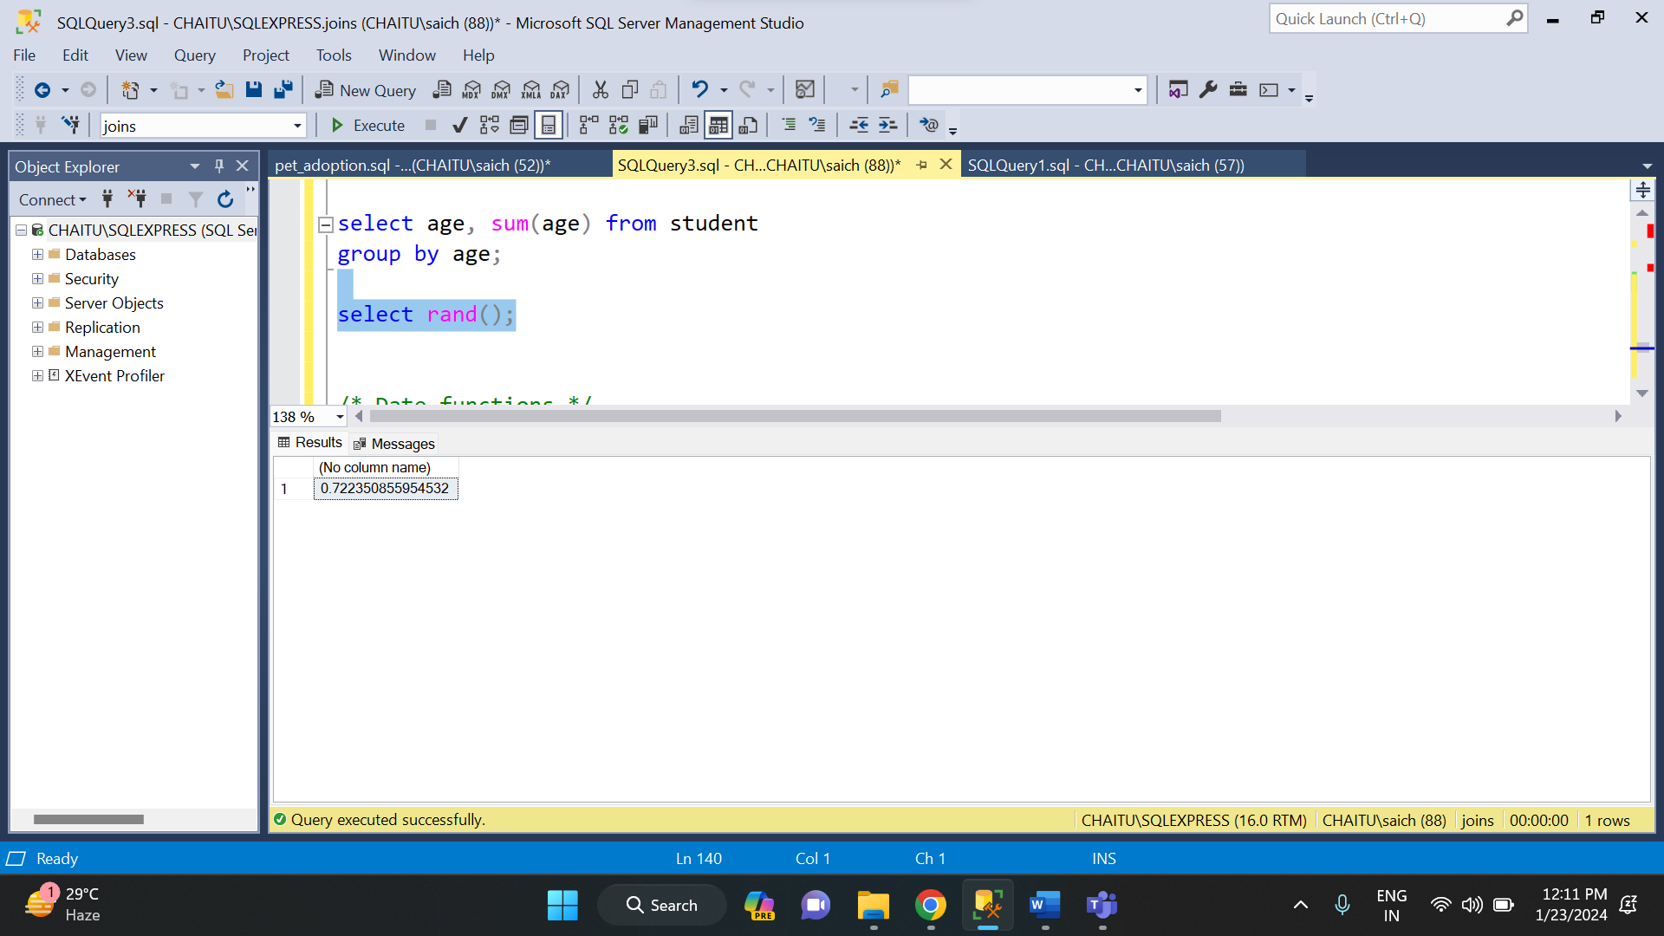

**DATE FUNCTIONS IN SQL:**

There are various date functions in SQL. They are:

* **GETDATE ():** This function is used to get the current date.

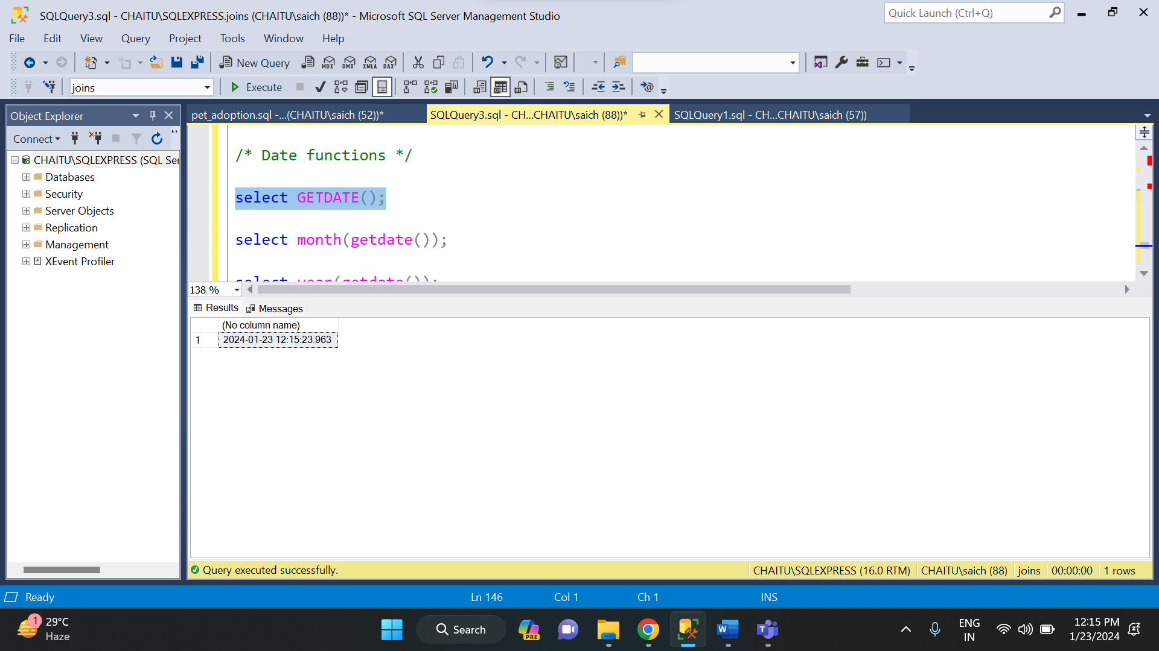

* **MONTH ():** It is used to get the month from a date.

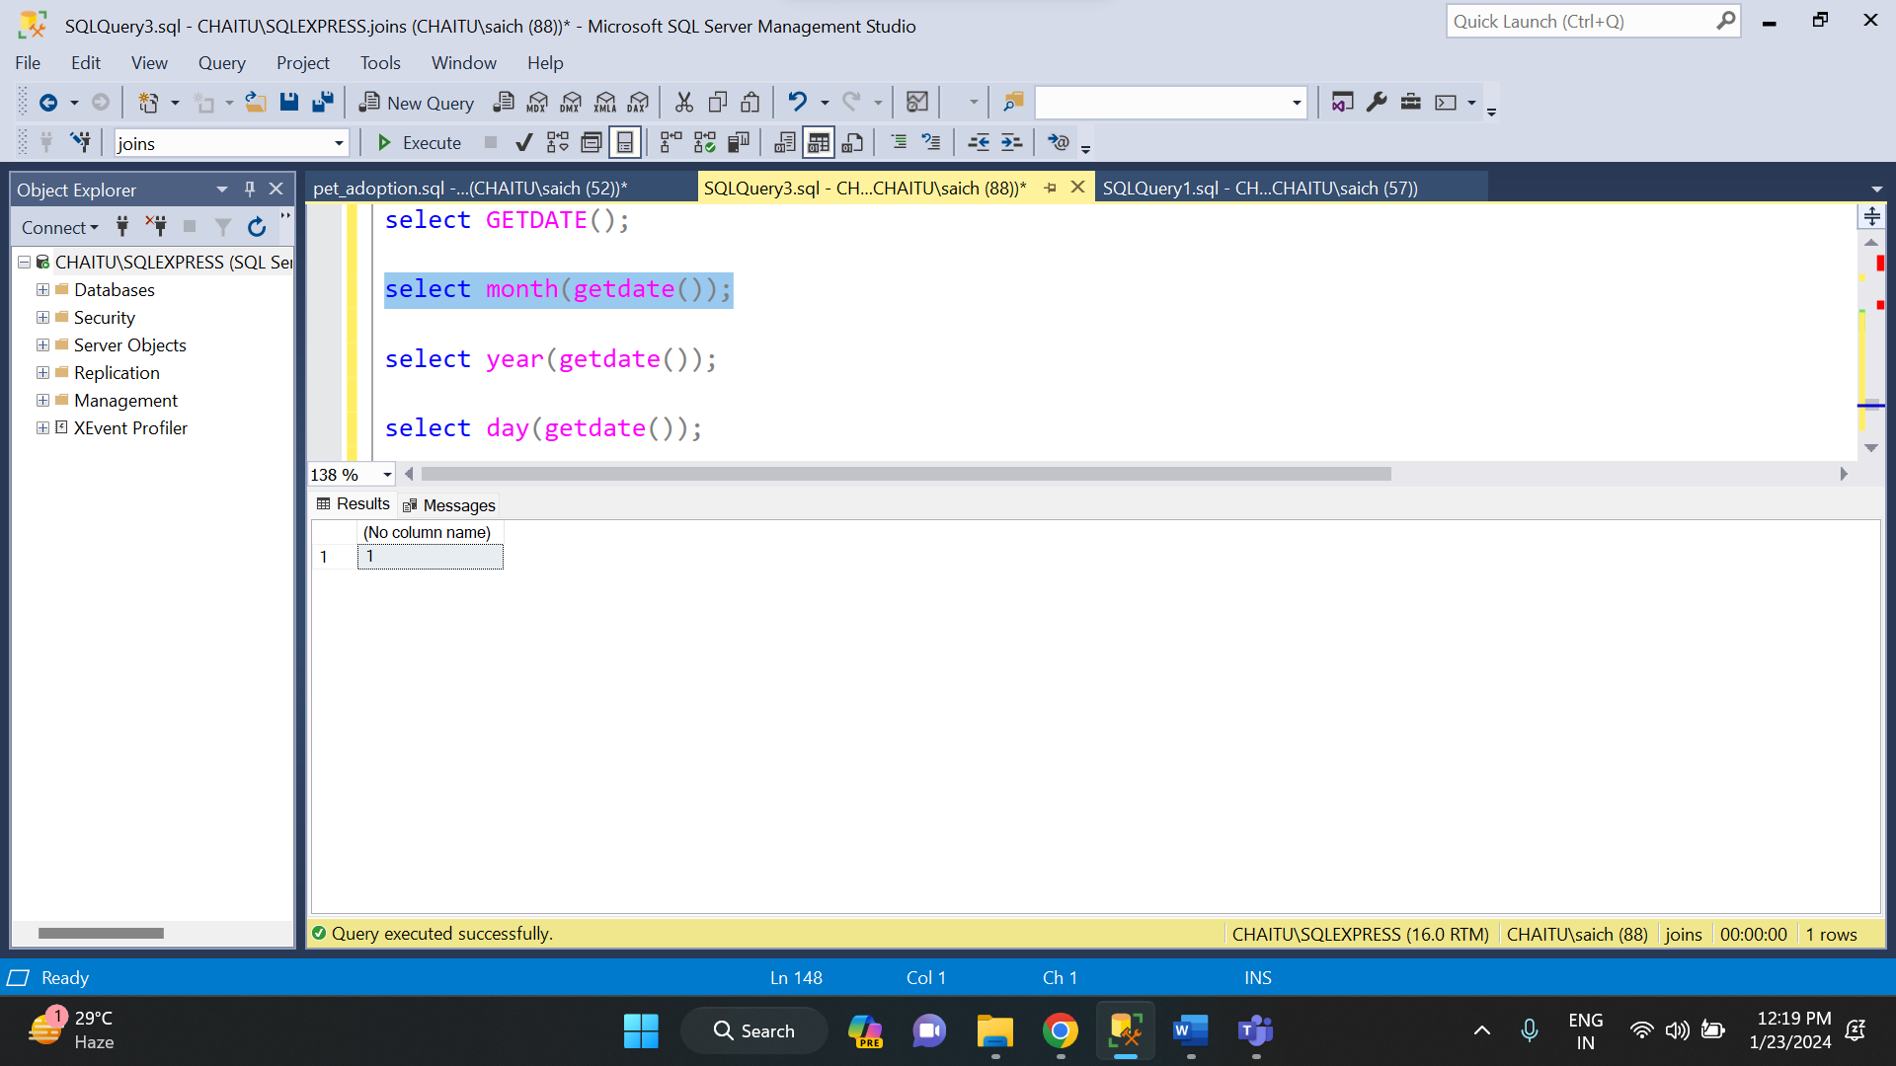

* **YEAR ():** It is used to get the year of a specified date.

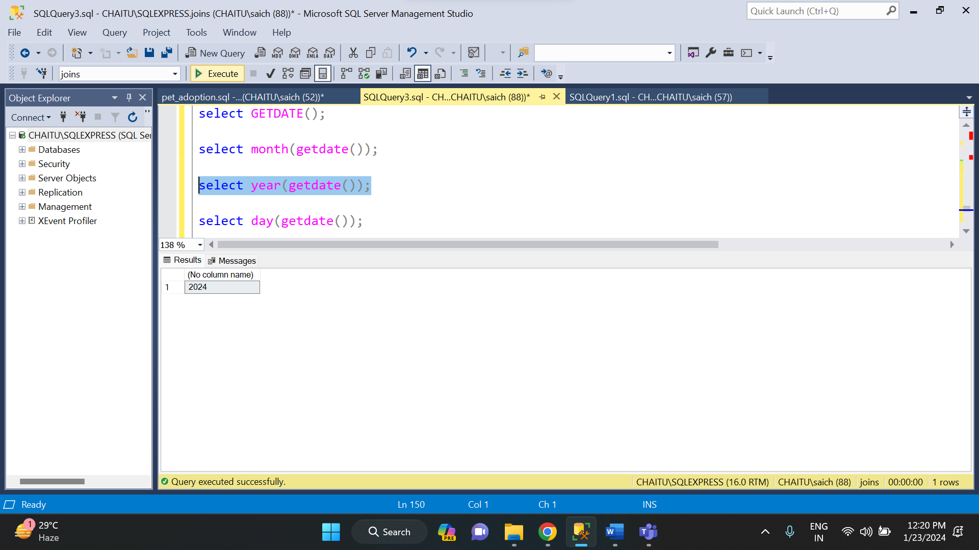

* **DAY (): I**t is used to get the day of a specified date.

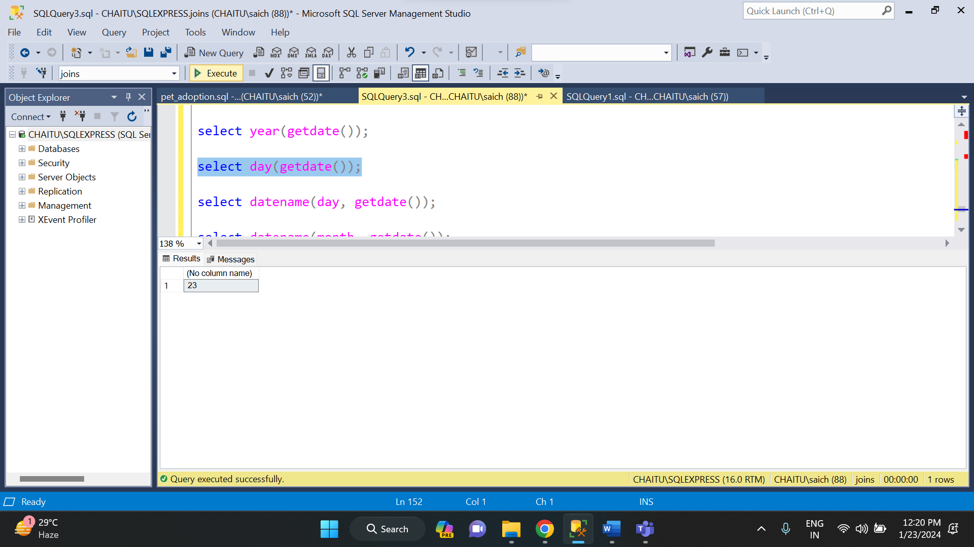

* **DATENAME ():** It is used to get the date name.

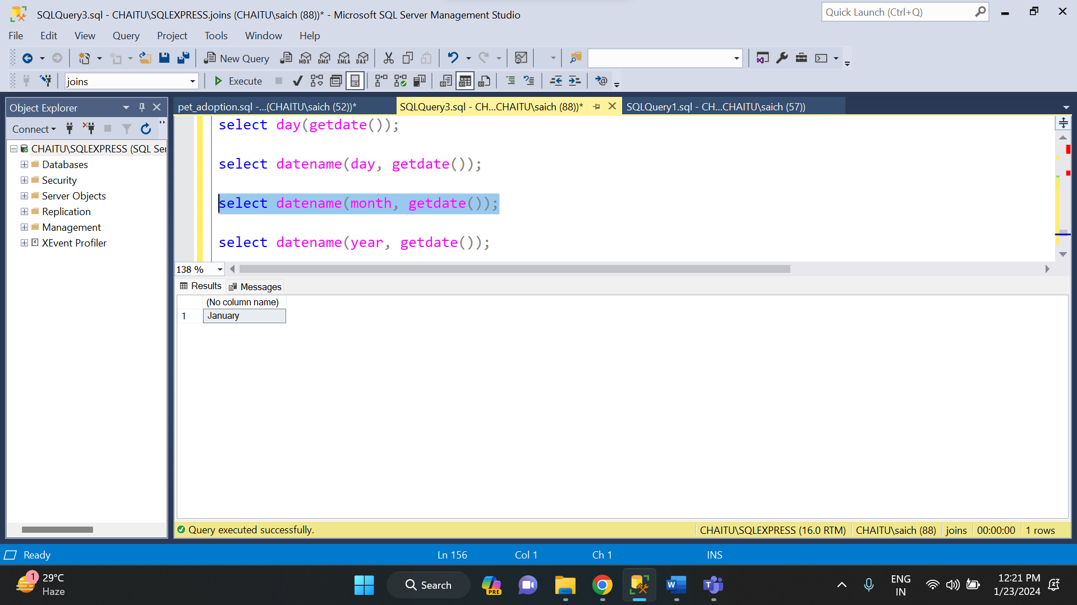

* **DATEPART ():** It is used to get the particular part from a date.

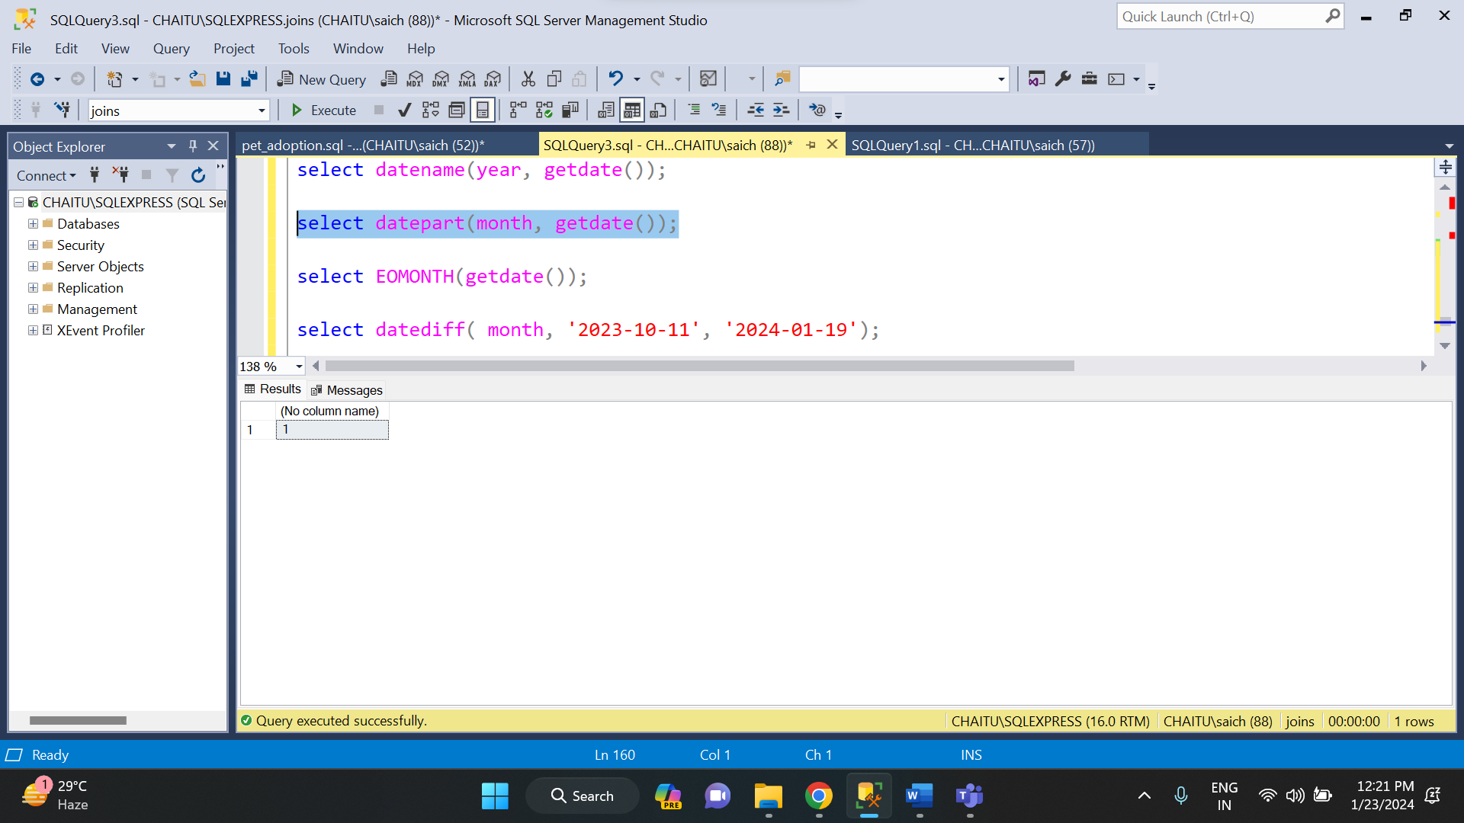

* **EOMONTH ():** This function is used to display the end date of a month.

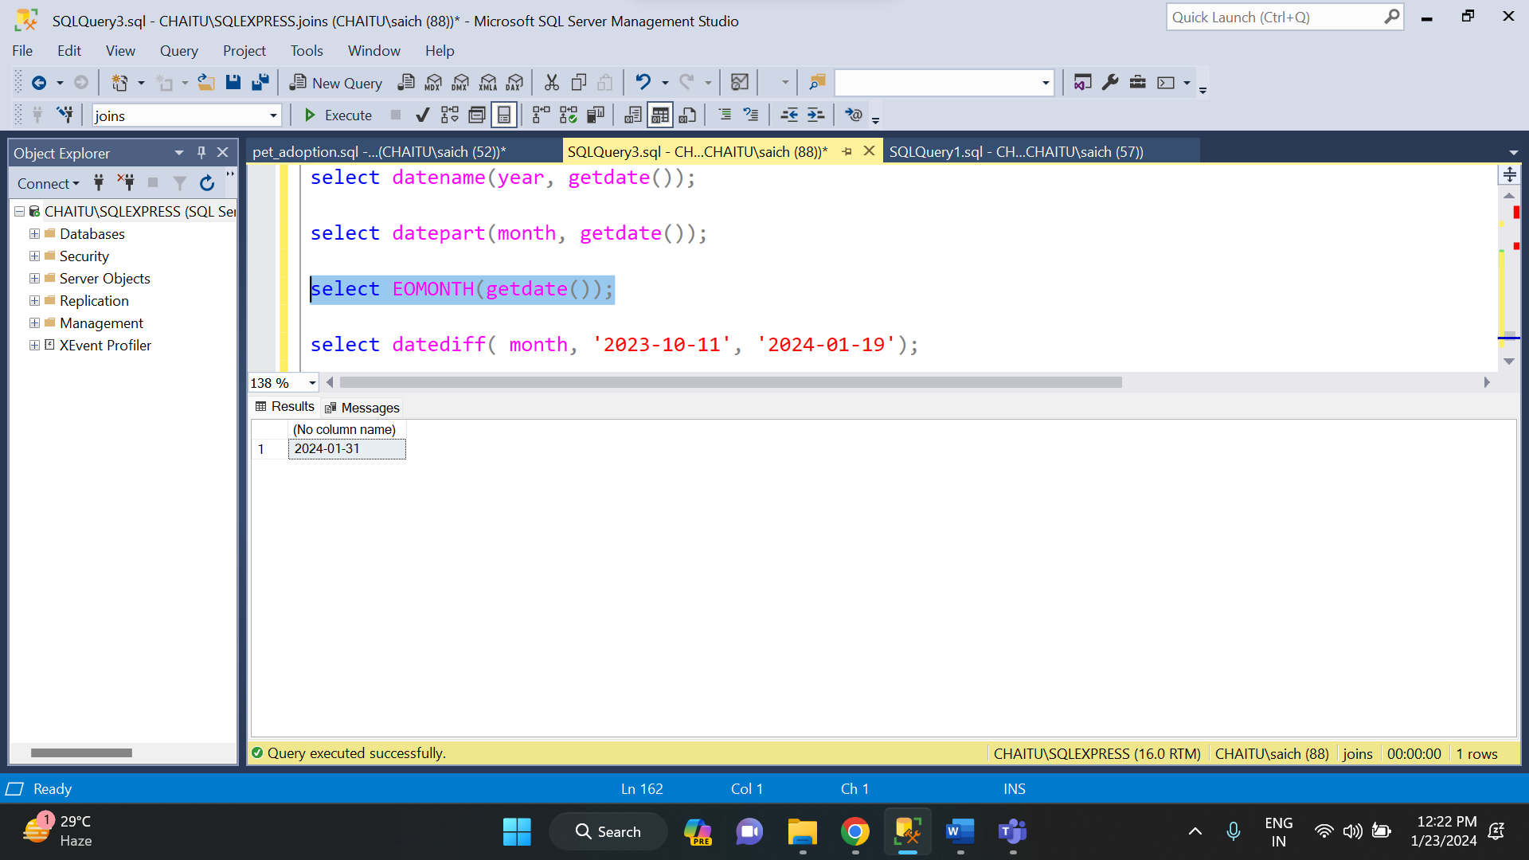

* **DATEDIFF ():** This function is used to find the difference between date based on day or month or year.

